FY2022 DANVILLE BUDGET COMMITTEE

Minutes of our January 12th, 2022 meeting

Chairperson Rob Collins called this meeting of the FY2022 Danville Budget Committee to order at 8:04 PM, with the following members present:

|  |  |  |  |
| --- | --- | --- | --- |
| Tom Billbrough | Not Present | Ed Lang | Present |
| Rob Collins * | Present | Sue Overstreet | Present |
| Sheila Johannesen *** | Present | Jeff Steenson ** | Not Present |

* Chairperson

** Vice Chairperson

*** BOS Representative

4130 Executive – per-230 NH Retirement System

Due to a reversal by the Board of Selectmen of the decision to enroll 3 full time employees into the NHRS a motion was made by Ed to remove $27,700 from the 4130 account, seconded by Sue. **APPROVED** 4-0.

4196 Insurance other

Based on new information provided by Kim Burnham we were asked to increase the 4196 Insurance other account from $51,140 to $65,302.

A motion was made to increase the 4196 account to $65,302 by Sheila and seconded by Ed. **APPROVED** 3-0-1 (Rob abtained).



The 1/6/2022 minutes were approved by general consent.

Sheila made a motion to enter the Public Hearing at 8:09PM, seconded by Ed. **APPROVED** 4-0.

**Public Hearing**

Rob reviewed the proposed budget.

2021 approved budget - $3,847,767 ($3,995,220 with approved warrant articles)

Proposed budget - $4,213,683 with changes made this evening.

Revenue budget - $1,554,450

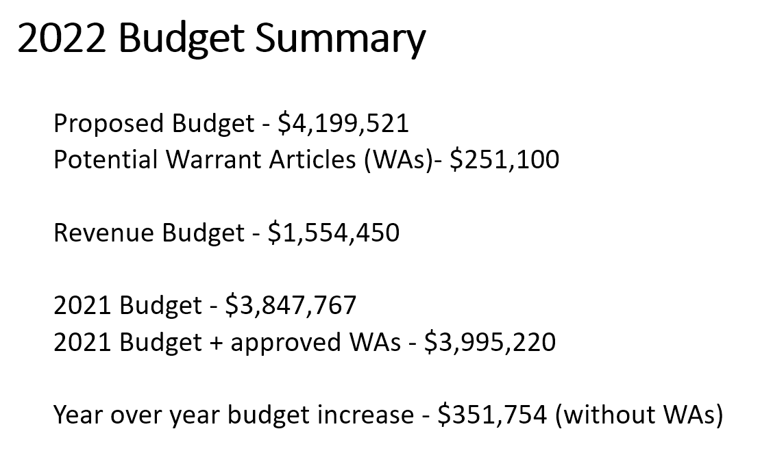

Rob reviewed the budget drivers



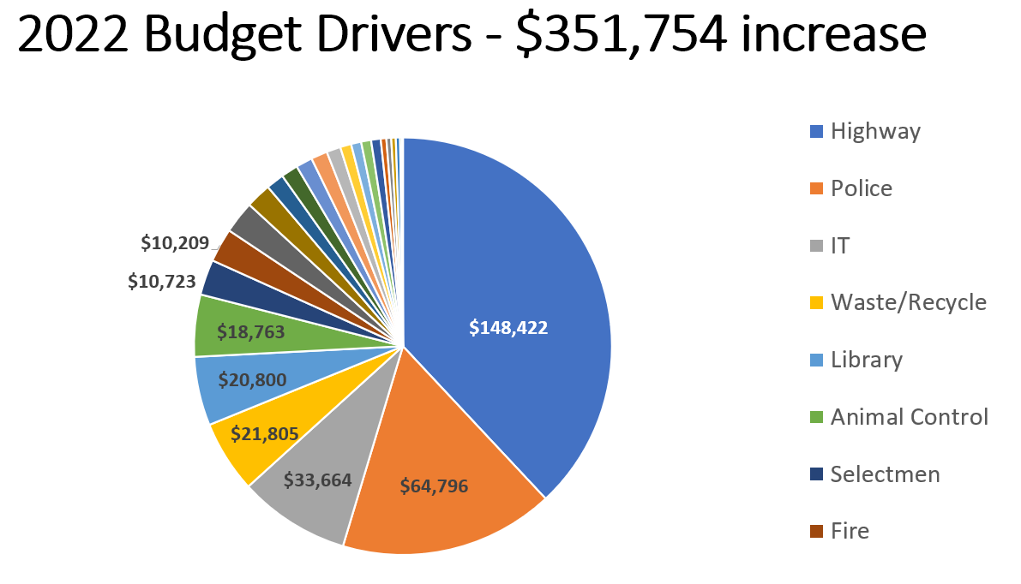

Historic trends were reviewed.

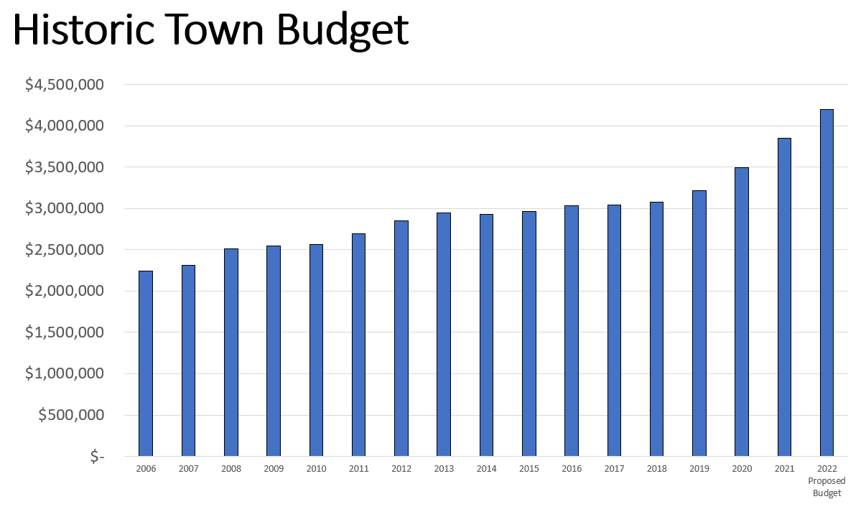

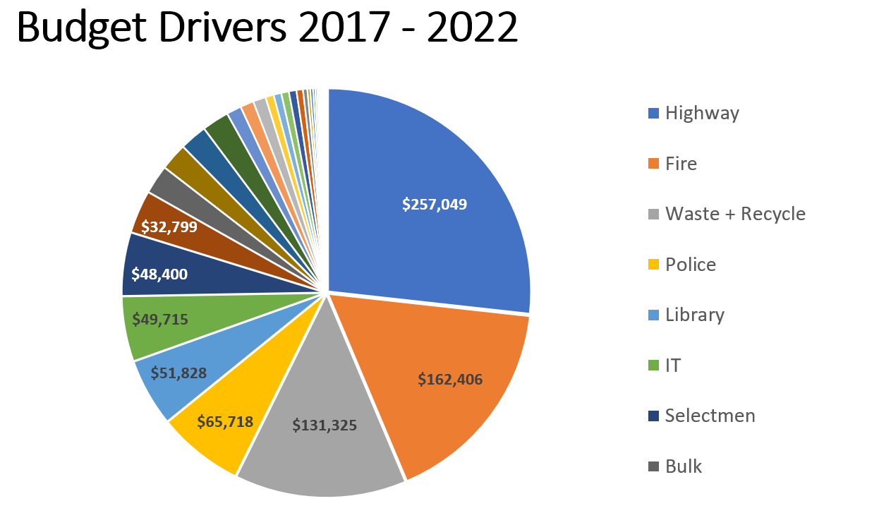

Rob asked if there were any questions about the proposed budget. Ann Massoth asked if unemployment and workman’s compensation was funded in the current proposed budget. Rob responded that these amounts were included in the 4155 Personnel account.

Rob reviewed the default budget because no one from the governing body was there to present. The default budget was prepared by Shawn O’Neil. Sheila was present but could not answer questions as to why or how the budget was put together. It appears the default budget was simply the BOS recommended budget minus a few items.

The RSA defining the default budget was read.

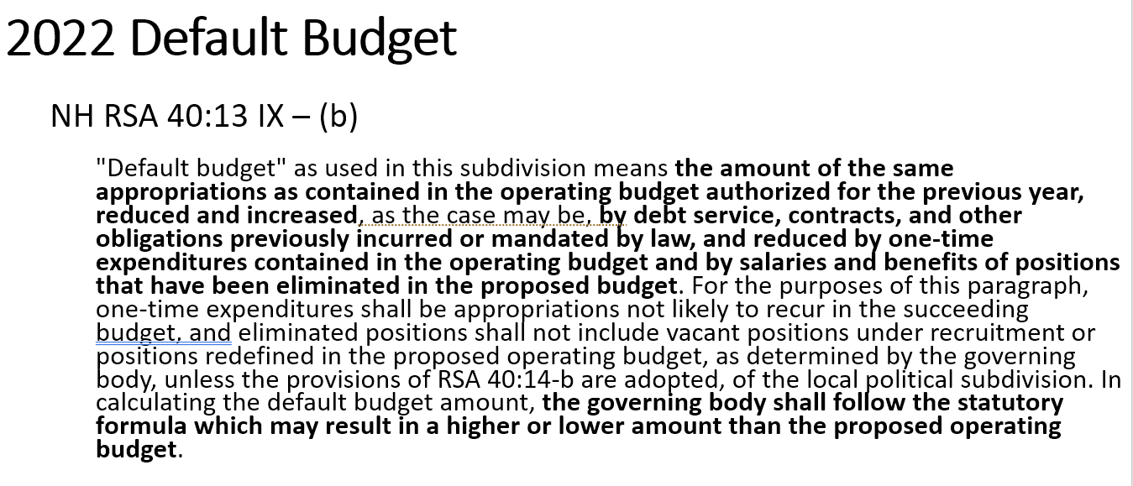



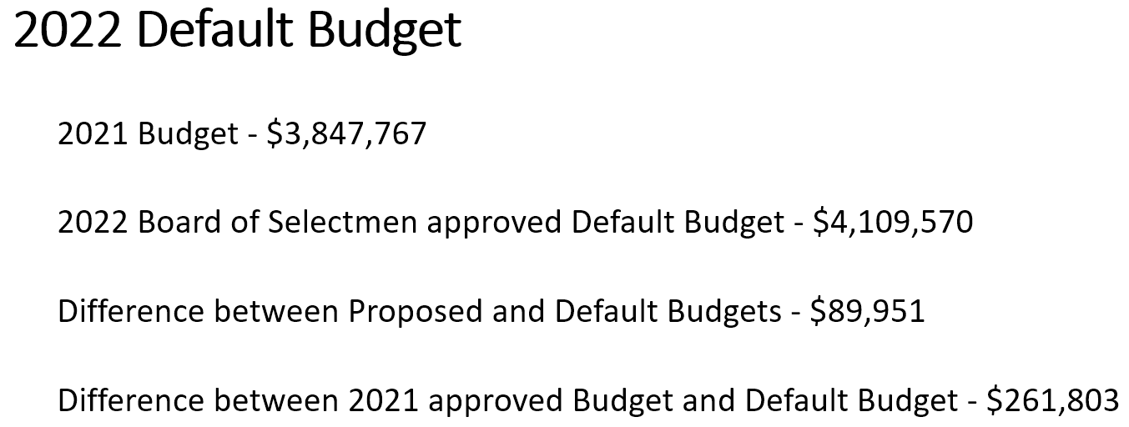

There were many questions about the default and how it was prepared that no one could answer. Sue expressed concern that the taxpayers are being slighted if the default budget isn’t prepared as determined by NH RSA 40:13. Rob said that he emailed the BOS in December about including salary increases in the default and that this should not be done. Rob was invited to discuss this with the BOS.

Rob reviewed the relevant warrant articles.

***Article 2022-8 Operating Budget***

Shall the Town of Danville raise and appropriate as an operating budget, not including appropriations by special warrant articles and other appropriations voted separately, the amounts set forth on the budget posted with the warrant or as amended by vote of the first session, for the purposes set forth therein, totaling $ _________________________. Should this article be defeated, the default budget shall be ***$4,109,570.00,*** which is the same as last year, with certain adjustments required by previous action of the Board of Selectmen or by law; or the governing body may hold one special meeting, in accordance with RSA 40:13, X and XVI, to take up the issue of a revised operating budget only.

**Recommended by the Board of Selectmen ( )**

**Recommended by the Budget Committee ( )**

*Estimated Tax Impact ____ per thousand*

***Article 2022-9 Fire Dept. Capital Reserve Fund for Future Fire Dept. Vehicle Purchases***

To see if the Town of Danville will vote to raise and appropriate the sum of $100,000.00 to be added to the Fire Dept. Capital Reserve Fund for Future Fire Dept. Vehicle Purchases previously established.

**Recommended by the Board of Selectmen (3-0)**

**Recommended by the Budget Committee (4-0)**

*Estimated Tax Impact $0.17373 per thousand*

***Article 2022-10 Highway Capital Reserve Fund***

To see if the Town of Danville will vote to raise and appropriate the sum of $20,000.00 to be added to the Highway Capital Reserve Fund for the purchase of future highway vehicles and equipment previously established.

**Recommended by the Board of Selectmen (3-0)**

**Recommended by the Budget Committee (5-0)**

*Estimated Tax Impact 0.03475 per thousand*

## Article 2022-11 Fire Department Equipment Capital Reserve Fund

To see if the Town of Danville will vote to raise and appropriate the sum of $15,000.00 to be added to the Protection of Personnel Equipment Capital Reserve Fund previously established for the future replacement of Self-Contained Breathing Apparatus (SCBA) to protect firefighters, previously established.

**Recommended by the Board of Selectmen (3-0)**

**Recommended by the Budget Committee (4-0)**

*Estimated Tax Impact 0.02606 per thousand*

***Article 2022-12***  ***Danville Infrastructure and Facility Non-Capital Reserve Fund***

To see if the Town of Danville will vote to raise and appropriate the sum of $10,000.00 to be added to the Danville Infrastructure and Facility Non-Capital Reserve Fund previously established.

**Recommended by the Board of Selectmen (5-0)**

**Recommended by the Budget Committee (5-0)**

*Estimated Tax Impact $0.01737 per thousand*

***Article 2022-13 not relevant to Budget Committee***

***Article 2022-14 Invasive Species Control Expandable Trust Fund***

To see if the Town of Danville will vote to raise and appropriate the sum of $10,000.00 to be added to the Milfoil Control Expendable Trust Fund, or if Article 8 passes, to be added to the Invasive Species Control Expendable Trust Fund for the purpose of management and eradicating the milfoil infestation found in Danville’s ponds/bodies of water and to name the Selectmen as agents to expend from this Milfoil Control Expendable Trust Fund.

**Recommended by the Board of Selectmen (5-0)**

**Recommended by the Budget Committee (5-0)**

*Estimated Tax Impact $0.01737 per thousand*

## Article 2022-15 Animal Control Vehicle Replacement Capital Reserve Fund

## To see if the Town of Danville will vote to raise and appropriate the sum of $5,000.00 to be added to the Animal Control Vehicle Replacement Non-Capital Reserve Fund for future Animal Control Vehicle Purchases previously established.

**Recommended by the Board of Selectmen (4-0-1)**

**Recommended by the Budget Committee (4-0-1)**

*Estimated Tax Impact $0.00869 per thousand*

## Article 2022-16 Colby Memorial Library Infrastructure and Facility Non-Capital Reserve Fund

To see if the Town will vote to raise and appropriate the sum of $5,000.00 to go into this fund for the engineering, repair, and renovation of facilities and the upgrade of the Colby Memorial Library’s infrastructure.

**Recommended by the Board of Selectmen (4-1)**

**Recommended by the Budget Committee (4-0)**

*Estimated Tax Impact $0.00869 per thousand*

***Article 2022-17***  ***Municipal Mosquito Control Expendable Trust Fund***

To see if the Town of Danville will vote to raise and appropriate the sum of $1,000.00 to be added to the Municipal Mosquito Control Expendable Trust Fund established for the purpose of management and spraying for mosquito control.

**Recommended by the Board of Selectmen (5-0)**

**Recommended by the Budget Committee (4-0-1)**

*Estimated Tax Impact 0.00174 per thousand*

## Article 2022-18 Colby Memorial Library Expend Interest

To see if the Town of Danville will vote to raise and appropriate, this year and each year in the future, the amount of interest income earned (not to exceed $100.00) from the library’s checking account and to authorize the Library Trustees to use the expenditure of those funds, annually, on books.

**Recommended by the Board of Selectmen (3-0)**

**Recommended by the Budget Committee (4-0)**

*No Tax Impact*

***Article 2022 -19, Article 2022-20 not relevant to Budget Committee***

***Article 2022-21 Modification of Elderly Exemption***

To see if the Town of Danville will vote to modify the elderly exemption from property tax in the Town of Danville, based on assessed value, for qualified taxpayers, to be the following: for a person 65 years of age up to 74 years, Ninety Six Thousand Dollars and no cents ($96,000.00); for a person 75 years of age up to 79 years, One-Hundred Thirty Seven Thousand Five Hundred Dollars and no cents ($137,500.00); for a person 80 years of age or older, One Hundred Sixty Nine Thousand Dollars and no cents ($169,000.00). To qualify, the person much have been a New Hampshire resident for at least three consecutive years, the person may own the real estate individually or jointly, or if the real estate is owned by such person’s spouse, they must have been married for at least 5 years and the property must be the primary residence. In addition, the taxpayer must have a net income of not more than Thirty-Three Thousand Six Hundred Dollars and no cent ($33,600.00) or, if married, a combined net income of less than Forty-Two Thousand Dollars and no cents ($42,000.00); and own net assets not in excess of Seventy-Three Thousand Five Hundred Dollars and no cents ($73,500.00) excluding the value of the person’s residence.” This article shall take effect for 2022 property tax year.

**Recommended by the Board of Selectmen (3-0)**

**Recommended by the Budget Committee (4-0)**

***Article 2022 -22, Article 2022-23 not relevant to Budget Committee***

At 8:45PM Ed made a motion to exit the Public Hearing, Sue seconded. **APPROVED** 4-0.

Rob asked the Committee if anyone wanted to make any changes to the budget. No changes were suggested.

With nothing further to discuss the meeting was adjourned at 8:49 PM.

Respectfully submitted,

Rob Collins

Chair